**CCNA 1 Chapter 11 V4.0 Answers 100% 2011**

1.

[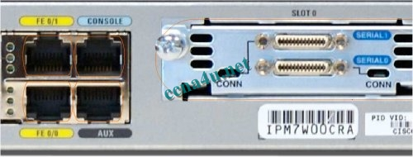](http://answers.ccna4u.net/wp-content/uploads/2011/02/1117.jpg)

**Refer to the exhibit. What command will place the router into the correct mode to configure an appropriate interface to connect to a LAN?**  
UBAMA# configure terminal  
UBAMA(config)# line vty 0 4  
UBAMA(config)# line console 0  
UBAMA(config)# interface Serial 0/0/0  
UBAMA(config)# interface FastEthernet 0/1

**2**. **In a Cisco router, when do changes made to the running-configuration take effect?**  
after a system restart  
**as the commands are entered  
when logging off the system

when the configuration is saved to the startup-configuration

**3**.

[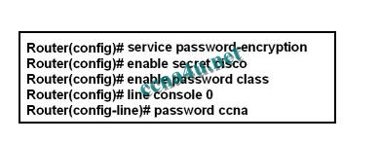](http://answers.ccna4u.net/wp-content/uploads/2011/02/11031.jpg)

**Refer to the exhibit. A technician applies the configuration in the exhibit to a clean router. To verify the configuration, the technician issues the show running-config command in the CLI session with the router. What lines should the technician expect to see in the router output from the show running-config command?**  
enable password class  
line console 0  
password ccna  
enable secret cisco  
enable password class  
line console 0  
password ccna  
enable secret 5 $1$v0/3$QyQWmJyT7zCa/yaBRasJm0  
enable password class  
line console 0  
password ccna  
enable secret cisco  
enable password 7 14141E0A1F17  
line console 0  
password 7 020507550A  
enable secret 5 $1$v0/3$QyQWmJyT7zCa/yaBRasJm0  
enable password 7 14141E0A1F17  
line console 0  
password 7 020507550A

**4**. **When network services fail, which port is most often used to access a router for management purposes?**  
AUX  
Ethernet  
Console  
Telnet  
SSH

**5**.

[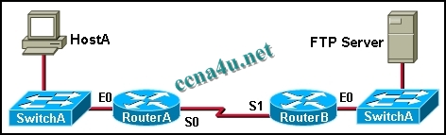](http://answers.ccna4u.net/wp-content/uploads/2011/02/11041.jpg)

**Refer to the exhibit. A network administrator on HostA has problems accessing the FTP server. Layer three connectivity testing was successful from HostA to the S1 interface of RouterB. Which set of commands will allow the network administrator to telnet to RouterB and run debug commands?**  
RouterB(config)# enable secret class  
RouterB(config)# line vty 0 4  
RouterB(config-if)# login  
RouterB(config)# enable secret class  
RouterB(config)# line vty 0 2  
RouterB(config-vty)# password cisco  
RouterB(config-vty)# login  
RouterB(config)# enable secret class  
RouterB(config)# line vty 0  
RouterB(config-line)# password cisco  
RouterB(config-line)# login  
RouterB(config)# enable secret class  
RouterB(config)# line aux 0  
RouterB(config-line)# password cisco  
RouterB(config-line)# login  
RouterB(config)# enable secret class  
RouterB(config)# line aux 0  
RouterB(config-vty)# password cisco  
RouterB(config-vty)# login

**6**. **Users in the network are experiencing slow response time when doing file transfers to a remote server. What command could be issued to determine if the router has experienced any input or output errors?**  
show running-config  
show startup-config  
show interfaces  
show ip route  
show version  
show memory

**7**.

[](http://answers.ccna4u.net/wp-content/uploads/2011/02/1114.jpg)

**Refer to the exhibit. Which names correctly identify the CLI mode represented by the prompt for Switch-East4#? (Choose two.)**  
line configuration mode  
user executive mode  
global configuration mode  
privileged executive mode  
interface configuration mode  
enable mode

**8**. **What command is used to change the default router name to Fontana?**  
Router# name Fontana  
Router# hostname Fontana  
Router(config)# name Fontana  
Router(config)# hostname Fontana

**9**.

[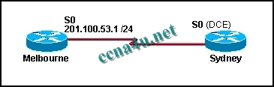](http://answers.ccna4u.net/wp-content/uploads/2011/02/1107.jpg)

**The serial connection shown in the graphic needs to be configured. Which configuration commands must be made on the Sydney router to establish connectivity with the Melbourne site? (Choose three.)**  
Sydney(config-if)# ip address 201.100.53.2 255.255.255.0  
Sydney(config-if)# no shutdown  
Sydney(config-if)# ip address 201.100.53.1 255.255.255.224  
Sydney(config-if)# clock rate 56000  
Sydney(config-if)# ip host Melbourne 201.100.53.2

**10**.

[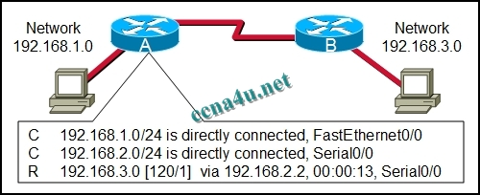](http://answers.ccna4u.net/wp-content/uploads/2011/02/1108.jpg)

**Refer to the exhibit. The output is shown for the show ip route command executed on Router A. What does the IP address 192.168.2.2 represent?**  
Gateway for the 192.168.1.0 network  
Gateway for the 192.168.3.0 network  
IP assigned to the serial port on Router A  
IP assigned to the serial port on Router B

**11**.

[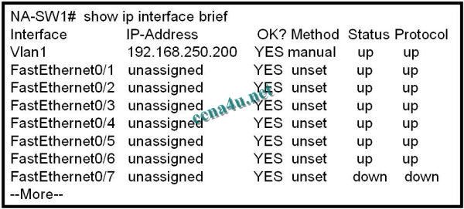](http://answers.ccna4u.net/wp-content/uploads/2011/02/1109.jpg)

**Refer to the exhibit. What additional command is required to allow remote access to this switch?**  
NA-SW1(config-if)# no shutdown  
NA-SW1(config)# enable password password  
NA-SW1(config)# ip default-gateway address  
NA-SW1(config-if)# description description

**12**. **Immediately after a router completes its boot sequence, the network administrator wants to check the routers configuration. From privileged EXEC mode, which of the following commands can the administrator use for this purpose? (Choose two.)**  
show flash  
show NVRAM  
show startup-config  
show running-config  
show version

**13**. **Which three terms correctly define the forms of help available within the Cisco IOS? (Choose three.)**  
hot keys  
context-check  
context-sensitive  
structured check  
command override  
command syntax check

**14**.

[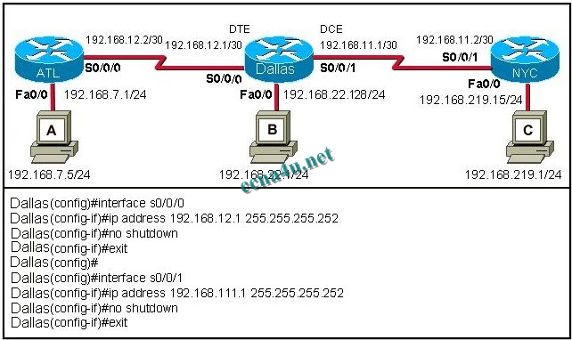](http://answers.ccna4u.net/wp-content/uploads/2011/02/1119.jpg)

**Refer to the exhibit. A student is responsible for the IP addressing, configuration and connectivity testing of the network shown in the graphic. A ping from host B to host C results in a destination unreachable but a ping from host B to host A was successful. What two reasons could account for this failure based on the graphic and partial router output for the Dallas router? (Choose two.)**  
The host A is turned off.  
The Fa0/0 interface on Dallas is shutdown.  
The LAN cable is disconnected from host B.  
The S0/0/1 IP address of Dallas is improperly configured.  
The Fa0/0 interface on Dallas is in a different subnet than host B.  
The clock rate is missing on the serial link between Dallas and NYC.

**15**. **Which combination of keys would be used at the CLI prompt to interrupt a ping or traceroute process?**  
Ctrl-C  
Ctrl-P  
Ctrl-R  
Ctrl-Shift-6  
Ctrl-Z

**16**.

[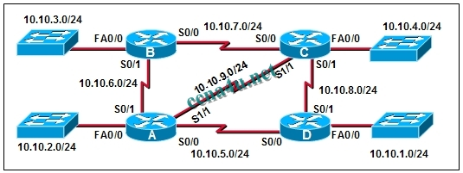](http://answers.ccna4u.net/wp-content/uploads/2011/02/1105.jpg)

**The connection between routers B and C has been successfully tested. However, after rebooting router C, the administrator noticed the response time between networks 10.10.3.0 and 10.10.4.0 is slower. Ping between the two routers is successful. A trace route indicates three hops from router B to router C. What else can be done to troubleshoot the problem?**  
Ping router B S0/1 connection from router C.  
Trace the connection between router B to router C S0/1.  
Issue a show ip route command in router B to verify routing is enabled.  
Issue a show interfaces command on router C.

**17**. **In a Cisco device, where is the IOS file stored prior to system startup?**  
RAM  
ROM  
Flash  
NVRAM

**18**. **On a Cisco router, which interface would be used to make the initial configuration?**

**[](http://answers.ccna4u.net/wp-content/uploads/2011/02/11181.jpg)**

[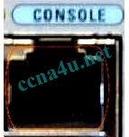](http://answers.ccna4u.net/wp-content/uploads/2011/02/11182.jpg)

Console (This option)

[](http://answers.ccna4u.net/wp-content/uploads/2011/02/11183.jpg)

**19**. **A network administrator needs to keep the user ID, password, and session contents private when establishing remote CLI connectivity with a router to manage it. Which access method should be chosen?**  
Telnet  
Console  
AUX  
SSH